U12 Games Manual 2024

Mayo Bord na nÒg statement,
"The Mayo GAA Child Safeguarding Statement has been prepared & adopted by Mayo GAA in accordance with the legislative requirements contained in the Children First Act 2015,

The Statement is a written statement that specifies the safeguarding service being provided by our Association and the principles and procedures that ensure, as far as practicable, that a child availing of our service is safe from harm."

Compliance:
Under the Children First Act, every person involved with players from six to eighteen years of age inclusive must be fully compliant with Child Welfare and Safeguarding Regulations i.e. be Garda Vetted within the last three years, have completed a Safeguarding Course within the last three years and have completed a Foundation Level Coaching Course. This is a legal obligation.

When citing official rules of the GAA we will always revert to the Irish abbreviation T.O.. Treoraí Oifigiúil (Official rules)

- All U12 games are in the Go Games model.
- No scores will be kept only the result.
- All competitions will be league format only, no knockout or finals.
- We will not publish the scores on our websites.
- Only the team who top the league will receive a set of medals, if it’s more than one team on top, they will all get a set of medals.
- The first league (Spring League) will be used for grading purposes, as it’s not permitted to use any age grade U12 for purposes of grading.
- You will have to present two team sheets for every single game you play as this is now part of the T.O.
- See rules link at back of manual.

Important dates;
- January 15th all club notices of amalgamations cooperations and for the year ahead must be with the county secretary secretary.mayo@gaa.Ie before this date. (A cooperation is where two clubs come together to form only one team in one age group)
- February 15th all notices of permission to play must be with the county secretary secretary.mayo@gaa.ie before this date. (Permission to play is where 4 or less players from another club come to play with a specified team in your club, anymore than four players and the name of the team needs to be changed)
- March 15th all club transfer requests must be with the county secretary secretary.mayo @gaa.ie before this date. Please note the official last date for a club transfer of 31st March. Only in exceptional circumstances will a transfer be permitted after this date.

What is the new structure for the U12 leagues in Mayo in 2024?
- The objective of these new set up is to ensure meaningful game time for all players at the U12 grade.
- Each club will set up U12 squads. Each club can have anywhere from 1 Squad to 4 Squads.
- Each squad to have 13 - 18 players in each squad. Or whatever number you can make work, You evenly divide your numbers so as to ensure that every player is getting adequate playing time.
- Games will be played on Wednesday and Friday’s can be used if needed.
- We will colour code the teams.
- Red is A. Green is B. White is C and Orange is D.
- Red and Green to definitely play on Wednesday while White and Orange can play on Wednesday or Friday’s.
- Our Plan is to send at least one referee to cover each squads game. So if you have two squads playing today against another clubs two squads, then we will try and have two refs there.
- Clubs can agree to move their games if they wish but will have to notify the Bord na nÓg beforehand so we can ensure a referee is present. This must be done through the secretary of the club only. See rule on postponing a game below.
- We still play the games as we did over the years and per the rules in our rules and regulations.
- It is important that every manger understands that this initiative is to ensure all players play and that no one is winning a County title of in with a chance of making an all ireland final. It’s just meaningful game time you are providing.

Postponing a game;
- You must first talk to your club secretary.
- You must then contact the opposing manager. Your secretary will get this number by contacting the other clubs secretary.
- If the other club agree to the postponement, then your club secretary needs to email assistantsecretary.mayo@gaa.ie.
- Your secretary must also CC on the email, the secretary of the opposition club.
- On the email, you will need to stipulate the next date and time that the game will be played at.
- Failure to put the next date and time will result in the game not being postponed and awarded to the opponent.
- You cannot postpone a game longer than 14 days. (You may request a postponement on exceptional circumstances but these are rarely granted.)
- You cannot postpone a game after the last round of the league.
- You cannot postpone a game after the next knockout round.
- This email needs to be in at least 48 hours before the throw in time of the original fixture.
- The names of both clubs, the grade, the time and the division must be included in the information on the email.
- The game is only postponed once your club secretary receives a confirmation email from the county board.
- Failure to observe the above process will result in the fixture loss to your team and a fine of €250 being imposed on your club.
- Postponing a game due to a bereavement can only be done if that person had a direct influence on the team. If it is a player or a manager or a parent of a player, then we will work with the club to ensure that everything can be done to accommodate your club. Unfortunately, we don’t postpone games for loss of grandparents unless they are proven to be the legal guardian of the child.

What if the pitch is unplayable?
- Only a referee has the power to deem a pitch unplayable. If however, you believe that your pitch in not playable on the day of the game,
- Then you must try and secure the services of another pitch locally.
- If you are unable to secure a pitch locally, then the fixture will be passed to the opposition club.
- If you do not notify the opposition and the referee at least four hours before the game, this will be deemed a forfeit of the game.
- This includes very wet pitches, so be sure to constantly check if your home pitch is playable in spring and autumn.

If our club books a pitch in the Centre of Excellence, who pays for it?
- Your club. Mayo GAA does not pay for pitches for club games.

What if our game clashes with a soccer match?
- Mayo GAA and Mayo Soccer held a meeting to discuss games clashes and where we were successful in getting nearly all our games agreed, sometimes our U12 games are going to clash, we ask clubs to work together to get a resolution and to remain respectful.
- Both organisations have massive numbers at this age grade and it is next to impossible to accommodate everyone.

I want to find out more information on a rule?
- Only your club secretary has the authority to ask about rules or rulings at any time.
- You are not permitted to contact the county board to ask about rules.

Will the county board have a list of contact details for the opposing managers of all teams?
- NO. GDPR laws means we are not permitted to store this sort of information as it is a high security risk.
- We have set up an online database that can be accessed by your club secretary. Only your club secretary will be able to see what’s on that excel file.
- We will never have that information to hand at any time. We are not permitted to share any of this information as the information of members of individual clubs is protected by your club at all times.

What if the referee doesn’t turn up?
- The county board do appoint referees to every single competitive game, sometimes referees are not able to travel and a replacement cannot be got in time.
- You can either agree between each manager to use the services of the local club referee if available.
- You can agree to use a club member if they have the necessary qualifications to referee a game.
- You can agree to referee the game yourselves.
- Ultimately, you may abandon the game but be cautious as the game may be re-fixed in a very short time to ensure continuity of our competitions.

Does it always have to be the club secretary who contacts the county board?
- Ultimately yes, but we do take emails from bord na nÓg secretaries if they are using a recognised @gaa.ie email account or an account previously approved by the Coiste na nÓg Maigheo.
- If the clubs bord na nÓg are contacting us, then they will need to CC the club secretary on all emails.
- Failure to CC the club Secretary will result in no response from Coiste na nÓg Maigheo.
- You should never contact the county board unless your secretary knows what’s happening.
- We will never reply to personal email addresses.

We want to hold our own U12/U11 blitz, what do we do?
- firstly you need permission from the Coiste na nÓg by getting your club secretary to email in the details.
- You need a full list of all the clubs taking part.
- You need a list of the referees officiating at the games.
- You are not to award a trophy.
- You can only hand out medals if everyone is getting a medal for taking part. (No winners).
- Please see the official rules of the GAA regarding the regulations on holding a Go Games age level tournament.

Silent Sidelines;
Silent sidelines are in operations for all U12 games in County Mayo.
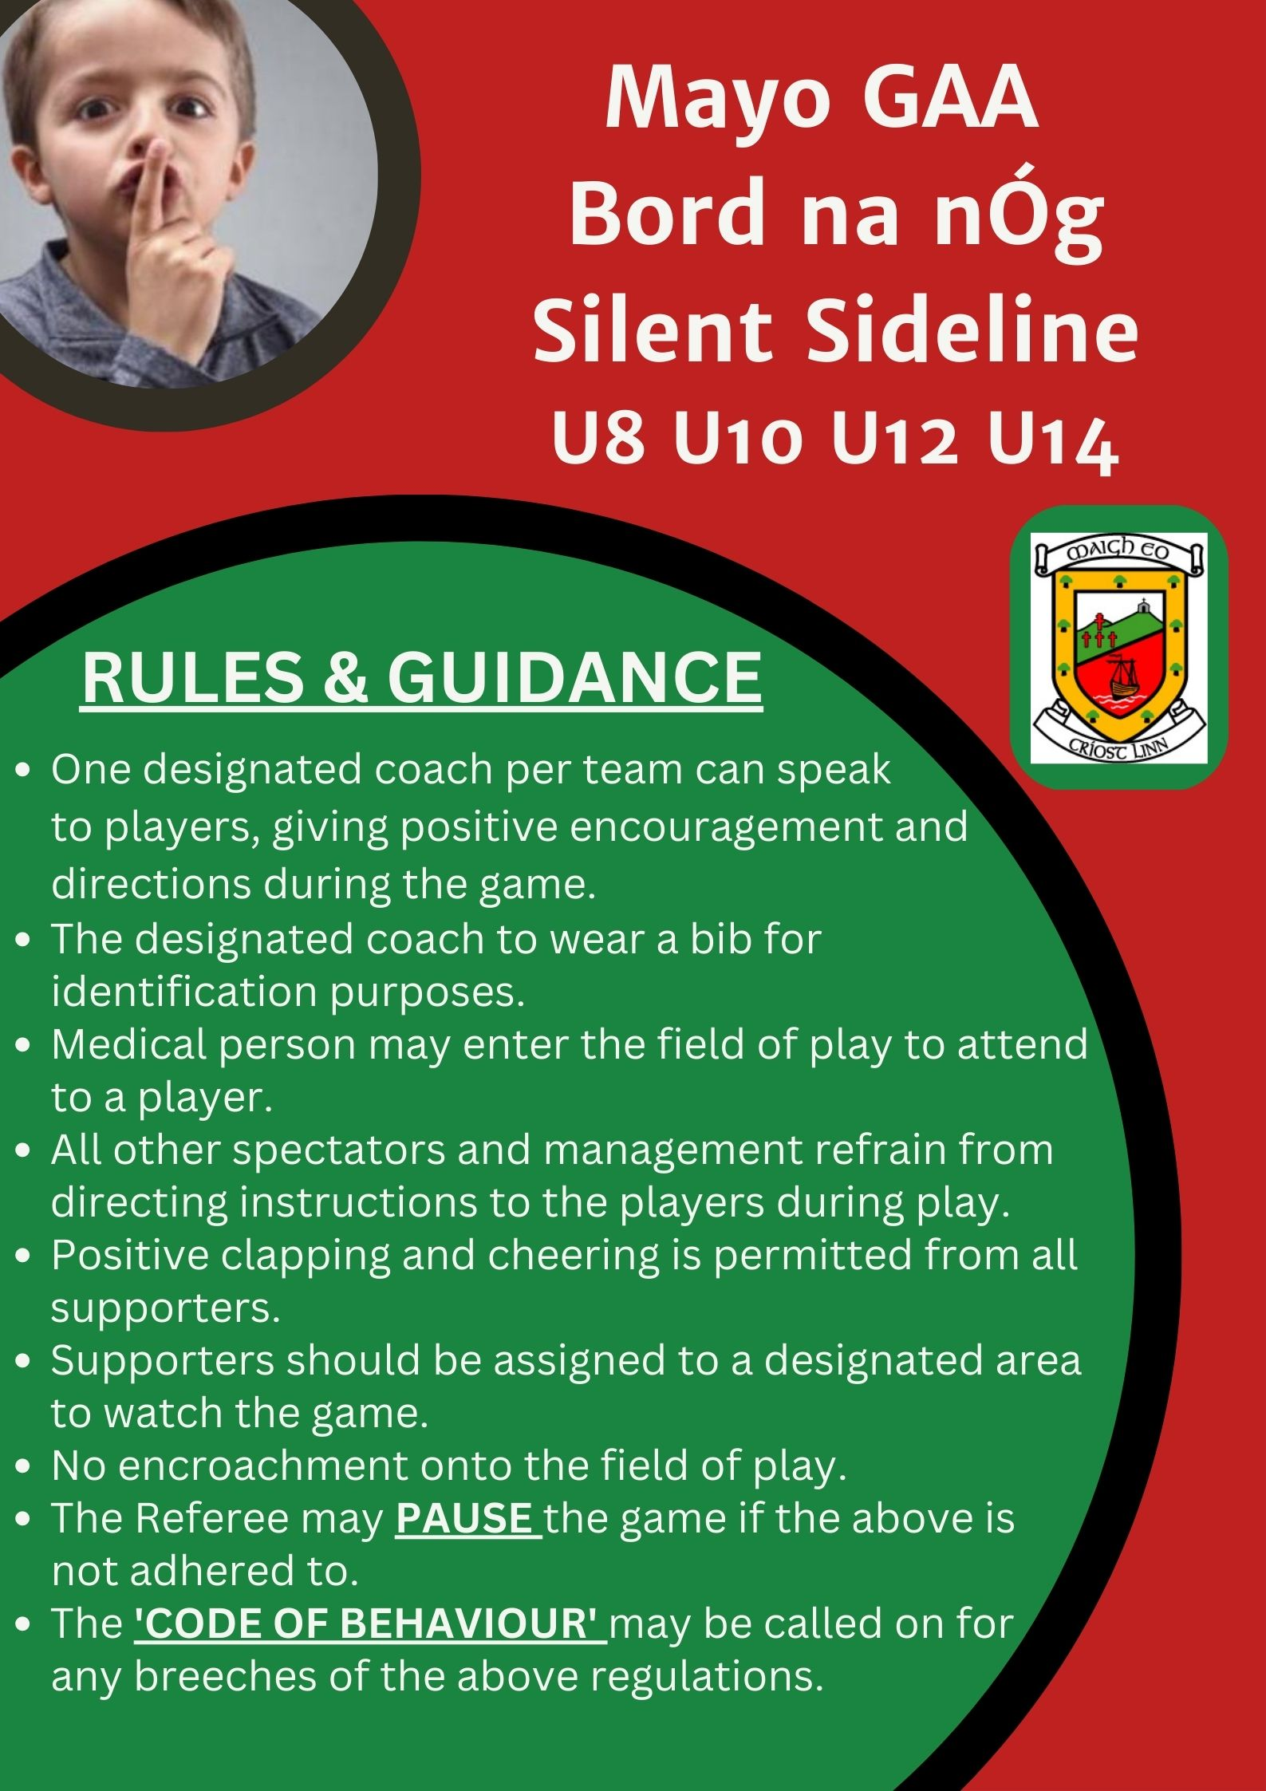

Dates for the year;
- These are the dates the U12 games are down for. Primarily Wednesday is the day you will play your games but you may use Friday if it’s convenient for the other teams also.
- Under rule, we cannot use any competition from U11 grade down for the purposes of grading and so must use the spring league to help us grade clubs every year.
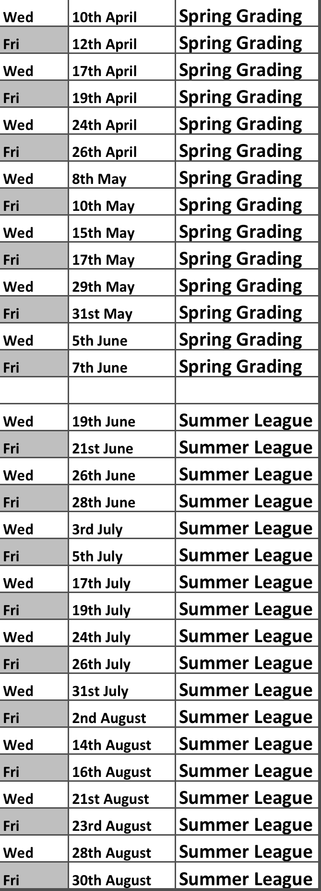

Useful links for underage managers,

Official rules of the GAA parts 1 & 2.
https://www.gaa.ie/api/pdfs/image/upload/xlasjshmfdcmfrynmvhz.pdf

https://www.gaa.ie/api/pdfs/image/upload/vybckve2iipp56xmjhqd.pdf

Official Code Rules of the GAA;
https://www.gaa.ie/api/pdfs/image/upload/rm0jrycjasokwfcltlfc.pdf

Code of behaviour;
https://www.gaa.ie/the-gaa/child-safeguarding-and-protection/code-of-behaviour

Code of conduct;
https://www.gaa.ie/api/pdfs/image/upload/ectlzpvl71cp2lpjd7my.pdf

Tusla report form,
https://www.gaa.ie/api/pdfs/image/upload/btxuy8ewvy72inheewcv.pdf

Guidance for dealing with abuse;
https://www.gaa.ie/api/pdfs/image/upload/vzga0aidmgm8ube5pozc.pdf

Child safeguarding and protection;
https://www.gaa.ie/the-gaa/child-safeguarding-and-protection/

