U16 & U14 Manual 2024
Mayo Bord na nÒg statement,
"The Mayo GAA Child Safeguarding Statement has been prepared & adopted by Mayo GAA in accordance with the legislative requirements contained in the Children First Act 2015,

The Statement is a written statement that specifies the safeguarding service being provided by our Association and the principles and procedures that ensure, as far as practicable, that a child availing of our service is safe from harm."
Compliance:
Under the Children First Act, every person involved with players from six to eighteen years of age inclusive must be fully compliant with Child Welfare and Safeguarding Regulations i.e. be Garda Vetted within the last three years, have completed a Safeguarding Course within the last three years and have completed a Foundation Level Coaching Course. This is a legal obligation.

https://www.gaa.ie/the-gaa/child-safeguarding-and-protection/

U16 games all will take place on Thursday evening’s. The usual time is 7pm.
U16 development league games will take place on Sunday mornings at 11am.
U14 games all will take place on Monday evening’s. The usual time is 7pm. (Exception to last round of league, semi finals and finals which are in a Tuesday).
U14 development league games will take place on Saturday mornings at 11am.
All competitions may be moved to make way for Hurling from time to time.

When citing official rules of the GAA we will always revert to the Irish abbreviation T.O.

Treoraí Oifigiúil (Official rules)
https://www.gaa.ie/api/pdfs/image/upload/xlasjshmfdcmfrynmvhz.pdf

https://www.gaa.ie/api/pdfs/image/upload/vybckve2iipp56xmjhqd.pdf

Official Code Rules of the GAA;
https://www.gaa.ie/api/pdfs/image/upload/rm0jrycjasokwfcltlfc.pdf

Division A and B or 1 and 2, will be 15 a-side competitions. Clubs competing in B or 2, May seek to play 13 a side by getting your club secretary to ask for permission by email. Permission must be sought at least a week before the start of the competition.
All games in all other leagues will be 13 a side,
UNLESS BOTH TEAMS HAVE 17 OR MORE PLAYERS, THEN THEY WILL HAVE TO PLAY 15 A-SIDE.
Important dates;
- January 15th all club notices of amalgamations cooperations and for the year ahead must be with the county secretary secretary.mayo@gaa.Ie before this date. (A cooperation is where two clubs come together to form only one team in one age group)
- February 15th all notices of permission to play must be with the county secretary secretary.mayo@gaa.ie before this date. (Permission to play is where 4 or less players from another club come to play with a specified team in your club, anymore than four players and the name of the team needs to be changed)
- March 15th all club transfer requests must be with the county secretary secretary.mayo @gaa.ie before this date. Please note the official last date for a club transfer of 31st March. Only in exceptional circumstances will a transfer be permitted after this date.

Postponing a game.
- You must first talk to your club secretary.
- You must then contact the opposing manager. Your secretary will get this number by contacting the other club's secretary.
- If the other club agree to the postponement, then your club secretary needs to email assistantsecretary.mayo@gaa.ie.
- Your secretary must also CC on the email, the secretary of the opposition club.
- On the email, you will need to stipulate the next date and time that the game will be played at.
- Failure to put the next date and time will result in the game not being postponed and awarded to the opponent.
- You cannot postpone a game longer than 14 days. (You may request a postponement on exceptional circumstances, but these are rarely granted.)
- You cannot postpone a game after the last round of the league.
- You cannot postpone a game after the next knockout round.
- This email needs to be in at least 48 hours before the throw in time of the original fixture.
- The names of both clubs, the grade, the time and the division must be included in the information on the email.
- The game is only postponed once your club secretary receives a confirmation email from the county board.
- Failure to observe the above process will result in the fixture loss to your team and a fine of €250 being imposed on your club.
- Postponing a game due to a bereavement can only be done if that person had a direct influence on the team. If it is a player or a manager or a parent of a player, then we will work with the club to ensure that everything can be done to accommodate your club. Unfortunately, we don’t postpone games for loss of grandparents unless they are proven to be the legal guardian of the child.
ONLY THE SECRETARY OF THE CLUB HAS THE AUTHORITY TO ASK FOR A POSTPONEMENT.

What if the pitch is unplayable?
- Only a referee has the power to deem a pitch unplayable. If however, you believe that your pitch in not playable on the day of the game,
- Then you must try and secure the services of another pitch locally.
- If you are unable to secure a pitch locally, then the fixture will be passed to the opposition club.
- If you do not notify the opposition and the referee at least four hours before the game, this will be deemed a forfeit of the game.
- This includes very wet pitches, so be sure to constantly check if your home pitch is playable in spring and autumn.

If our club books a pitch in the Centre of Excellence because our pitch is unplayable, who pays for it?
- Your club. Mayo GAA does not pay for pitches for clubs whose pitches are unplayable.
- It is your responsibility to provide an alternative pitch not the Bord na nÓg or Mayo GAA.

I want to find out more information on a rule?
- Only your club secretary has the authority to ask about rules or rulings at any time.
- You are not permitted to contact the county board to ask about rules.
- Please also see a link attached or alternatively you may google GAA rules, 1, 2 and GAA codes.

Will the county board have a list of contact details for the opposing managers of all teams?
- NO. GDPR laws means we are not permitted to store this sort of information as it is a high security risk.
- We have set up an Excel file on the GAA sharepoint here clubs can submit this information and secretaries of clubs can access to see contact details.
- We will never have that information to hand at any time. We are not permitted to share any of this information as the information of members of individual clubs is protected by your club at all times.
- The only way for you to get the opposition managers number is for your secretary to contact the secretary of the opposition club and ask for it or to access the excel file on sharepoint in the one drive.

What if the referee doesn’t turn up?
- The county board do appoint referees to every single competitive game, sometimes referees are not able to travel and a replacement cannot be got in time.
- You can either agree between each manager to use the services of the local club referee if available.
- You can agree to use a club member if they have the necessary qualifications to referee a game.
- You can agree to referee the game yourselves.
- Ultimately, you may abandon the game but be cautious as the game may be re-fixed in a very short time to ensure continuity of our competitions.

Does it always have to be the club secretary who contacts the county board?
- Ultimately yes, but we do take emails from bord na nÓg secretaries if they are using a recognised @gaa.ie email account or an account previously approved by the Coiste na nÓg Maigheo.
- If the clubs bord na nÓg are contacting us, then they will need to CC the club secretary on all emails.
- Failure to CC the club Secretary will result in no response from Coiste na nÓg Maigheo.
- You should never contact the county board unless your secretary knows what’s happening.
- We will never reply to personal email addresses.
- Clubs have been asked to set up bord na nog email addresses if they want to contact us.

We wish to appeal a decision by the referee after the game?
- This situation is rare but can happen.
- When this does happen, then your club secretary must send an email to the County Secretary secretary.mayo@gaa.ie.
- No other email address is acceptable.

How to appeal a red card?
- When a player commits a foul and receives a red card for it, they must leave the playing area immediately.
- After the game is over, the referee will fill out a report and send it into the County Secretary.
- The County Secretary then will send the report to the CCC for observation.
- The CCC will deliberate the case and if necessary, will issue the club with the recommended penalty.
- The County Secretary will email the club with the penalty notice and then the person or persons charged have 48 hours to respond to the notice.
- All further information will be on the penalty notice issued.
- Please be sure to read up on penalties and how they are served in the official rules of the GAA.

What is the silent sideline at U14 level in Mayo?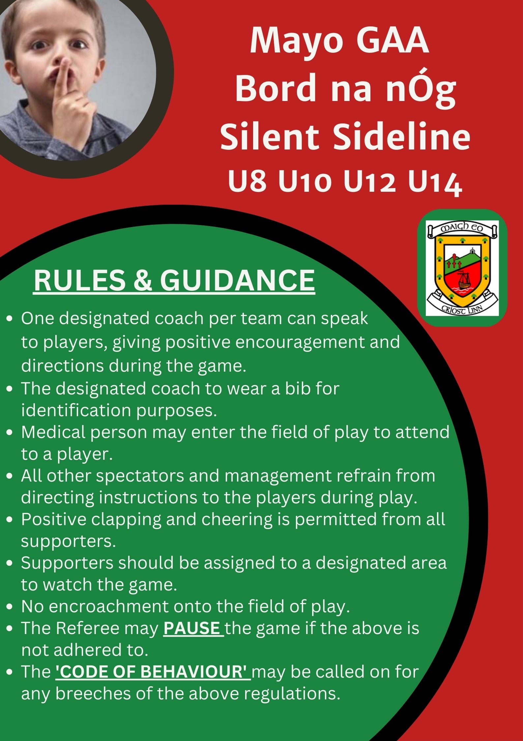

Useful links for underage managers,
Official rules of the GAA parts 1 & 2.
https://www.gaa.ie/api/pdfs/image/upload/xlasjshmfdcmfrynmvhz.pdf

https://www.gaa.ie/api/pdfs/image/upload/vybckve2iipp56xmjhqd.pdf

Official Code Rules of the GAA;
https://www.gaa.ie/api/pdfs/image/upload/rm0jrycjasokwfcltlfc.pdf

Code of behaviour;
https://www.gaa.ie/the-gaa/child-safeguarding-and-protection/code-of-behaviour

Code of conduct;
https://www.gaa.ie/api/pdfs/image/upload/ectlzpvl71cp2lpjd7my.pdf

Tusla report form,
https://www.gaa.ie/api/pdfs/image/upload/btxuy8ewvy72inheewcv.pdf

Guidance for dealing with abuse;
https://www.gaa.ie/api/pdfs/image/upload/vzga0aidmgm8ube5pozc.pdf

Child safeguarding and protection;
https://www.gaa.ie/the-gaa/child-safeguarding-and-protection/

 | Fèile | U14 | U16
9th March |  | Round 1 League
21st March |  |  | Round 1 League
23rd March |  | Round 2 League
28th March |  |  | Round 2 League
30th March |  | Development League
31st March |  |  | Development League
6th April |  | Development League
7th April |  |  | Development League
8th April |  | Round 3 League
11th April |  |  | Round 3 League
13th April |  | Development League
14th April |  |  | Development League
15th April |  | Round 4 League
18th April |  |  | Round 4 League
20th April | Hurling Feile Mayo
21st April |  |  | Development League
22nd April |  | Round 5 Leagues
25th April |  |  | Round 5 League
27th April |  | Development League
28th April |  |  | Development League
29th April |  | Round 6 League
2nd May |  |  | Round 6 League
4th May |  | Development League
6th May | County Feile
9th May | County Feile
11th May |  | Development League
12th May |  |  | Development League
14th May |  | Round 7 League
16th May |  |  | Round 7 League
17th May |  | Play-Off
18th May |  | Development League
19th May |  |  | Play-Off U16 + Dev
21st May |  | Semi-Finals
23rd May |  |  | Semi- Finals
25th May |  | Development League
26th May |  |  | Development League
28th May |  | Finals (Neutral Venues)
29th May
30th May |  |  | Finals (Neutral Venues)
31st May
1st June |  | Development League
2nd June |  |  | Development Leagues
22nd June | Hurling Feile Final
24th June |  | Divisional Rd. 1
27th June |  |  | Divisional Rd. 1
29th June | Football Feile Final
1st July |  | Divisional Rd. 2
4th July |  |  | Divisional Rd. 2
8th July |  | Divisional Rd. 3
11th July |  |  | Divisional Rd. 3
15th July |  | Divisional Rd. 4
18th July |  |  | Divisional Rd. 4
22nd July |  | Championship
25th July |  |  | Championship
29th July |  | Championship
1st August |  |  | Championship
12th August |  | Championship
15th August |  |  | Championship
19th August |  | Play-off
22nd August |  |  | Play-off
26th August |  | Semi-Finals
29th August |  |  | Semi-Finals
2nd Septembe | 5.30pm/7.00pm | Championship Finals
3rd September | 5.30pm/7.00pm | Championship Finals
4th September | 5.30pm/7.00pm | Championship Finals
5th September | 5.30pm/7.00pm |  | Championship Finals
6th September | 5.30pm/7.00pm |  | Championship Finals
7th September | 5.30pm/7.00pm |  | Championship Finals

