Go Games Manual

## Mayo Bord na nÒg statement,

"*The Mayo GAA Child Safeguarding Statement has been prepared & adopted by Mayo GAA in accordance with the legislative requirements contained in the Children First Act 2015,*

*The Statement is a written statement that specifies the safeguarding service being provided by our Association and the principles and procedures that ensure, as far as practicable, that a child availing of our service is safe from harm."*

## Compliance:

Under the Children First Act, every person involved with players from six to eighteen years of age inclusive must be fully compliant with Child Welfare and Safeguarding Regulations i.e. be Garda Vetted within the last three years, have completed a Safeguarding Course within the last three years and have completed a Foundation Level Coaching Course. This is a legal obligation.

## When citing official rules of the GAA we will always revert to the Irish abbreviation T.O.. Treoraí Oifigiúil (Official rules)

## Below are some links to online courses and resources for Go Games managers and trainers.

<https://www.gaa.ie/article/go-games-online-referee-course-and-activity-weeks-2024?s=08>

<https://www.gaa.ie/article/researchers-endorse-go-games-with-some-parental-education-required?s=08>

## What are Go Games, see link below,

<https://www.gaa.ie/my-gaa/getting-involved/go-games>





## Silent Sidelines are in operation for all Go Games

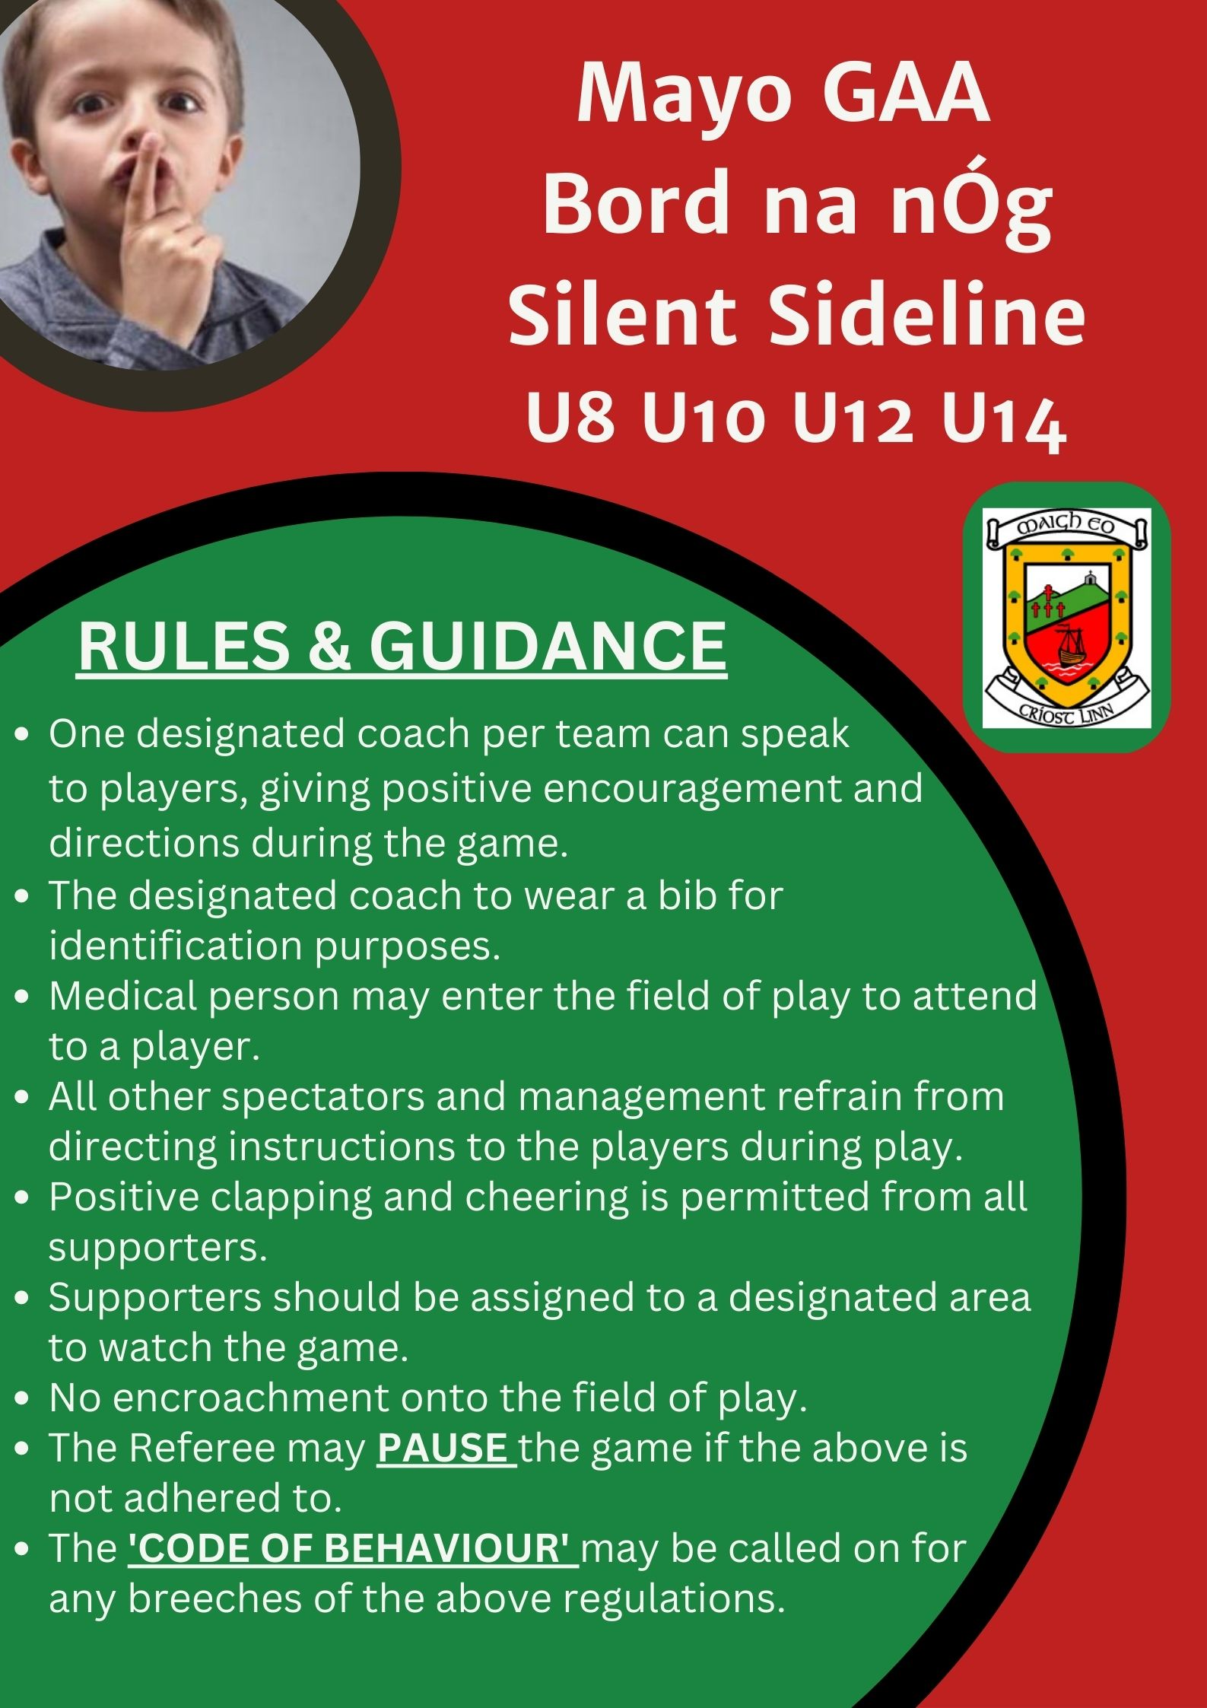

## Blitzes for 2024 Guidelines,

Managers, what to do and not to do,

* Arrive at least 30 minutes before the first game starts.
* Be respectful of the host club and its members.
* All host clubs will have their own format that will work for them so respect it as it may not be what you did before.
* When reffing a blitz game, you cannot coach your own team, only encourage all players.
* Each manager should take turns at reffing games.
* Remember, there is nothing at stake at the end of the game only whether the child had fun or not.
* It is your duty to ensure every child gets game time during the blitz.
* It is always advised to bring your own equipment with you as your host club may not have enough to go around.
* It is always advisable to bring water and snacks with you just incase.
* Ensure that the Give Respect Get Respect hand shake take place after every game.

## Hosting Blitzes,

what to do and not do,

* Welcome every club and person to your grounds with no prejudice.
* Ensure your pitches are cut and have cones available to mark pitches.
* As we are reducing the size of the teams attending, it is still advisable to have some stewards for parking on the day.
* Ensure that the Give Respect Get Respect hand shake take place after every game.
* No provision is made to publish scores, to play on a knock-out basis nor to include semi-finals, finals, etc.
* No provision is made to present trophies, cups etc. in any code and competition/league from U12 and below. Where certificates/medals are presented in lieu of participation, the same certificate/medal must be presented to every participant.

**Qualities of a Coach**

The coaching style needed will depend on the age or group being coached. However, some of the qualities a coach needs are transferable across all age groups. A good coach is

**Positive:**A coach should always try make everyone’s experience of Gaelic Games positive, by being approachable, encouraging and considerate of each player’s needs.

**Enthusiastic:**A coach should always be upbeat and optimistic with the players, with appropriate verbal and body language.

**Supportive:**A coach should always be supportive of players and show empathy when required.

**Organised:**A coach should be organised and prepared, so they can be fully focused when it’s time for

training and matches.

**Trusting:**The coach should work to earn the trust of the players and not abuse that trust. The coach should also trust the players to make decisions when the opportunity may be there.

**Focused:**A coach should be focused on providing an environment where their players, the team and club are at the centre of actions.

**Goal-oriented:**A coach should have some goals or guidelines they want the players or teams should strive for depending on their age and level.

**Knowledgeable:**A coach should have some knowledge of the game and rules, but also in how to adapt training sessions and keep it fresh and enjoyable.

**Observant:**A coach should practice observation during training and games to get a better understanding of certain patterns of behaviour both positive and negative.

**Respectful:**A coach should always be respectful of the players, club, officials and the game.

**Patient:**A coach needs patience and understand that development is a long-term process, where the fruits of their labour may not be noticeable for many years after their interaction

**Reflective:**Reflective practice can be a significant contributor to coach development

**Clear communicator:**A coach needs to communicate their messages clearly and effectively to all. They need to understand that some may need more direction than others but to be clear, patient and respectful always.

**In Session Coaching**

As we are primarily advocating the use of the games-based approach and this is the best practice in coaching games (8 steps):

• Gather Attention:

Get the groups attention, use whistle/clap/loud voice, whatever you as a coach are comfortable with

• Introduce game and link it to skill:

Explain what game we are going playing, the rules of the game and what is the focus skill and why it’s important.

• Demonstrate and explain skill

Demonstrate skill either yourself/another coach or even a player if you wish. Use 1-3 key teaching points for the skill(cues)

• Question to check for understanding

Use questions to see if players understand what you’re asking of them (body language a key indicator at this point)

• Play the game

Let them at it with little instruction

• Pause game and correct where necessary (**most important step**)

This is the real area of coaching.

• Spot and raise awareness of issues arising

• Endorse what they are doing

• Coach by Comparison, which would be better do you think X or Y or which is fastest way to move ball? Kicking or soloing

• Coach by Questioning, how can we improve? Where should you move when X has the ball etc.

• Resist the temptation to tell your players what to do, you should with skillful questioning get them to come up with the answers themselves. You will have guided them to the answer which is much more beneficial in the long-term. This is a crucial process in player development.

• Play the game

Go back into the game and see if the player will adjust, again let them play with little instruction. Give them time to adjust to the correction process

• End/Debrief

End the exercise and endorse two or three points that was good and one area for improvement. Question the players and see if they can come up with the answers and ask what they have learned.

Reinforce club values and appreciation, thank the players and vice-versa

**U10 Blitz dates and teams**



Go Games Dates

Round 1 May 4th

Round 2 June 1st

Round 3 June 29th

Round 4 July 27th

Round 5 August 24th

## U8 Blitz dates and teams

|  |  |  |  |  |  |
| --- | --- | --- | --- | --- | --- |
|  | **22nd June** | **3rd August** |  | **22nd June** | **3rd August** |
|  | **Castlebar Mitchels** | **Westport St. Patricks 1** |  | **Ballina Stephenites** | **Beal an Mhuirthead** |
|  | Ballinrobe | Ballinrobe |  | Beal an Mhuirthead | Cill Chomain |
|  | Breaffy | Islaneady |  | Ardmoy | Ardnaree Sarsfields |
|  | Knockmore | Tuar Mhic Eadaigh |  | Cill Chomain | Bonniconlon |
|  | Islaneady | Burrishoole |  | Erris St.Pats | Erris St.Pats |
|  | |  |  | |  |
|  | **Westport St. Patricks 1** | **Louisburg** |  | **The Neale** | **Mayo Gaels** |
|  | Louisburg | Westport St.Patricks 2 |  | Claremorris | Ballintubber |
|  | Lahardane McHaels | Parke Keeloges Crimlin |  | Shrule Glencorrib | Carras |
|  | Achill | Breaffy |  | Mayo Gaels | Davitts |
|  | Balla | Achill |  | Hollymount Carramore | Shrule Glencorrib |
|  | |  |  | |  |
|  | **Moy Davitts** | **Knockmore** |  | **Kilmeena** | **Kiltimagh** |
|  | Aghamore | Naomh Padraig |  | Ballintubber | The Neale |
|  | Naomh Padraig | Crossmolina Dell Rovers |  | Ardnaree Sarsfields | Claremorris |
|  | Crossmolina Dell Rovers | Lahardane McHaels |  | Bonniconlon | Hollymount Carramore |
|  | Swinford | Balla |  | |  |
|  | |  |  | **Ballaghaderreen** | **Ardmoy** |
|  | **Charlestown Sarsfields** | **Ballyhaunis** |  | Kiltimagh | Ballina Stephenites |
|  | Eastern Gaels | Aghamore |  | Davitts | Ballaghaderreen |
|  | Kilmovee Shamrocks | Kilmovee Shamrocks |  | Carras | Kilmeena |
|  | Ballyhaunis | Charlestown Sarsfields |  |  |  |
|  | |  |  |  |  |
|  | **Tuar Mhic Eadaigh** | **Moy Davitts** |  |  |  |
|  | Westport St.Patricks 2 | Eastern Gaels |  |  |  |
|  | Burrishoole | Swinford |  |  |  |
|  | Parke Keeloges Crimlin | Castlebar Mitchels |  |  |  |

## Round 1 April 27th

## Round 2 May 11th

Round 3 May 25th

Round 4 June 8th

Round 5 June 28th **@7.00pm**

Round 6 July 6th

Round 7 July 20th

Round 8 August 17th

Round 9 August 31st

## Important Resources for you,

<https://www.gaa.ie/api/images/image/upload/t_q-best/frd3g5ztkictmem1lwqu.pdf>

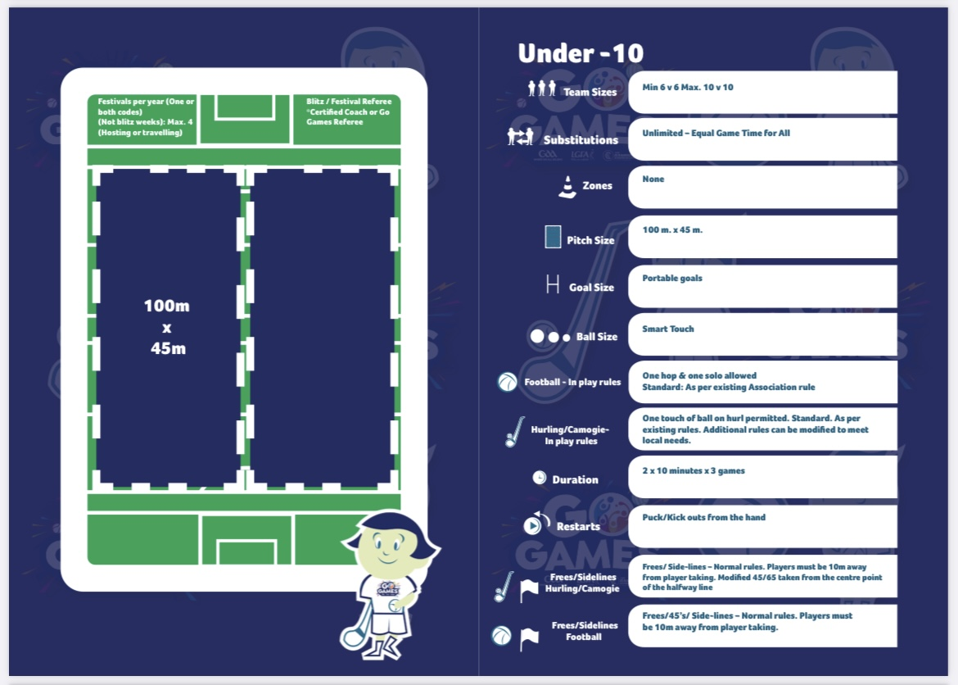

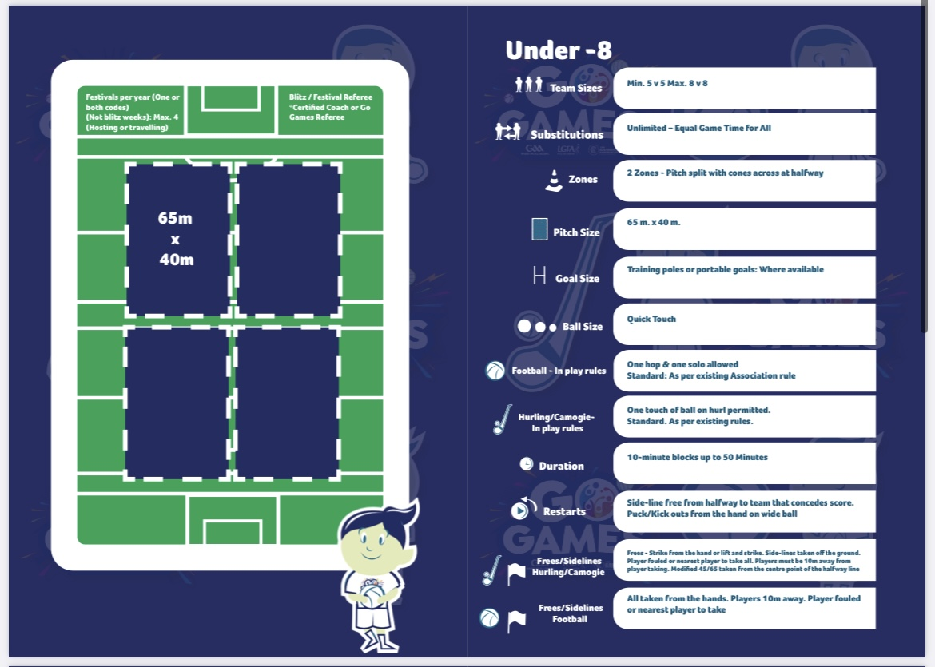

**Below are some links to online courses and resources for Go Games managers and trainers.**

<https://learning.gaa.ie/node/283614>

<https://www.gaa.ie/article/researchers-endorse-go-games-with-some-parental-education-required?s=08>

**What are Go Games, see link below,**

<https://www.gaa.ie/my-gaa/getting-involved/go-games>

**Important Resources for you,**

<https://www.gaa.ie/api/images/image/upload/t_q-best/frd3g5ztkictmem1lwqu.pdf>

